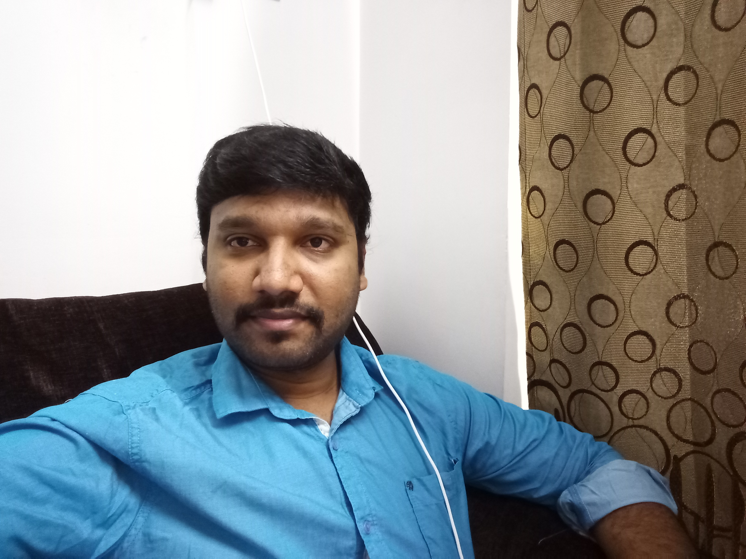 | Bakthavatchalam. G  A/1, Anna street,  New Perungalathur,  Chennai - 600063
  gbakthavatchalam@gmail.com
  +91-9710257197

About Me

Lead Python Developer/Technical Lead

Passionate, result-oriented software programmer with 8+ years’ experience leading and working in product development companies across multiple domains like financial, networking etc. Lead multiple successful projects starting from requirement gathering, requirement analysis, requirement documentation, resource planning, time and cost estimations, solution designing, people management and release management. Possess hands-on experience on wide-variety of tools and technologies throughout my career. Prioritized and managed multiple projects within scope and time constraints.

Skills include:

- Project Estimation | - Release Management | - Requirements Gathering & Analysis
- Team Leadership | - Solution Design | - Talent Acquisition
- Strong Financial Domain Experience | - Agile / Scrum Methodologies | - Hardcore Development, Troubleshooting & Debugging

Core Competencies

Lead Python Developer
  - Passionate and skilful developer with high level of expertise in Python language and its related tools.
  - 6 years of experience in financial domain including 3 years of experience at BA Continuum India Pvt Ltd
  - Experience in different areas like Web Development, API Development, Front End Design, Web Services, Automation Scripting, Databases including NoSQL.
  - Experience in performance tuning and optimization
  - Experience in advanced practices like TDD and BDD.
  - Experience in building automated unit test suites.
  - Experience in incorporating few design patterns within the project scope.
  - Experience in team handling and mentorship.
  - Experience in Agile methodologies.
  - Experience in building and maintaining Continuous Integration pipelines.
  - Experience in tools like AWS, ServiceNow, GIT, SVN, Eclipse, PyCharm, Sublime, BugZilla, JIRA, Redmine, Amazon Alexa etc.

Project Schedule/Release Management
  - Hands on project scheduling, tracking and release management experience on various projects.
  - Good knowledge and experience on Software development methodologies and test processes.
  - Good knowledge of software testing cycles – Functional, Regression, Acceptance.

Education

Bachelor of Engineering, Computer Science and Engineering
Anna University, Chennai, India |  | 2005-2009
 | Work Experience

Oct 2018 – Till date: As Technical Lead in Prodapt Solutions Chennai

Jun 2016 – Oct 2018: As Technical Lead/Lead Python Developer in AppViewX Inc, Coimbatore

July 2014 – May 2016: As Analyst – Apps Programmer in BA Continuum India Pvt Ltd, Chennai.

Jun 2013 – Jun 2014: As Analyst – Apps Programmer in Helios & Matheson India Pvt. Ltd, Chennai.

Oct 2009 – May 2013: As Senior Software Engineer in Gain Credit Inc (formerly known as Global Analytics), Chennai.

Software Exposure

Software Development:
Languages Java/J2EE, Python, Javascript
DevOps Tools Docker, Vagrant
Frameworks and Platforms Flask, Django, TDD, BDD, Unit Test, REST
User Interfaces HTML, CSS, jQuery, KnockoutJS, React Native
Data Representation/Exchange XML, JSON
Web Service Protocols REST, SOAP
Databases MySQL, MS SQL Server, MongoDB, ElasticSearch, Redis
Operating System Unix/Linux, Windows
CI Tools Buildbot, GIT, SVN, GitLab CI
IDEs Eclipse, PyCharm, Sublime
Change Management Tools ServiceNow, CA Service Desk Manager, JIRA, Redmine
ADC Technologies F5 LTM GTM, AVI
DNS Technologies Infoblox, Bluecat IPAM, BT Diamond
Clould Technologies Amazon Web Services
Firewall Technologies Juniper, Checkpoint
Security Technologies SSL Certificate/Key Life Cycle Management

Product / Project Details

Project – I

Title : Observer

Environment : Python, Elasticsearch, Redis, MySQL, Django, Flask
Company : Prodapt Solutions
Client : Liberty Global
Description : Observer is a network performance management, monitoring and visualization tool within LG.
Period : 5 months
Team Size : 15
Designation : Technical Lead

Role Played

- Senior Python Developer
- Web API development using Python and related tools
- Participating in client requirement gathering discussions and demonstrations calls.

Project – II

Title : AppViewX - Network Workflow Automation Suite– Plugin Development

Environment : Python, F5, Juniper, Citrix, ServiceNow, Infoblox, Bluecat
Company : AppViewX Inc
Description: AppViewX is a network infrastructure management suite that helps orchestrate and automate provisioning on top of the infrastructure by interacting with relevant tools.
Period : 18 months
Team Size : 20
Designation : Lead Python Developer

Role Played

- Technical Lead/Lead Developer
- Being able to explore and perform POC on wide variety of tools like F5, Juniper, Cisco, Infoblox, Bluecat network devices
- Playing as a technical consultant with respect to automation in python
- Participating in client requirement gathering discussions and demonstrations calls.
Project – III

Title : Diamond

Environment : Python, Flask, jQuery, Knockout, SQLAlchemy, MS SQL Server
Client Name : Bank of America
Description: Diamond is part of the Global Market Risk Technology at Bank of America. It helps in managing and mitigating risks that may occur because of various models employed at various lines in the bank. It is a workflow tool which helps in managing the lifecycle of various statistical models , their approval, their signoffs from stakeholders and finally their deployment at the bank. It helps in calibrating each model and assign a potential risk score based on its operating line of business.
Period : 3 years
Team Size : 6
Designation : Analyst – Apps Programmer
Role Played

- Full Stack developer working with Python, MSSQL, Javascript, ORM etc
- Working in an agile environment and following best practices including test driven development
- Created a test suite useful for unit testing of sql alchemy mapping classes
- Implemented reporting component for the application
- Attending requirement gathering calls, discuss ,get clarified about the requirements.
Project – IV

Title : Underwriting Engine v 1.0
Environment : Web service, Python, Mod_Python, MySql 5.1
Client Name : Lending Stream LLC
Company : Global Analytics

Description: Designing and developing a credit rating engine for online payday lending business in UK. Identifying customer application variables, real time analysing of credit reports from third-party data bureau like Experian, running through past loan performances of the customer and generating profile scores, analysing the repayment patterns and generating risk scores.
Period : 2 years
Team Size : 10
Designation : Software Engineer
Role played
- Involved in the initial discussions with the product stakeholders to understand the requirement and converting them into technical requirement specification document.
- Was involved in a series of database design and data flow management meetings.
- Worked in a group of 5 people towards delivering the project
- Unit testing, Staging and Production deployment

Project – V

Title : Fraud Pattern Detection Service.

Environment : SOAP Web service, Python, Mod_Python, MySql 5.1
Client Name : LendingStream LLC/ Zebit LLC
Company : Global Analytics

Description: Closely interacting with Fraud management team and identifying cases of potential frauds by analyzing the applicants data. For example, sample rules can be, restricting multiple loan applications from same geographical area, restricting multiple loan applications using the same bank account number, customers behaviour on the website etc. Designing and developing a web service which accepts customers fraud-sensitive information and running through various fraud rules and models and decisioning the current loan application.
Period : 6 months
Team Size : 2
Designation : Senior Software Engineer
Role played

- Understanding the Business Requirements Specification (BRS).
- Created a generic SOA layer for any such services of its kind
- Closely emulated a SOAP library without any WSDL specification, but with simple configuration files.
- Helped in identifying potential rules that could possible detect suspicious customers.
- Implented fraud models as per the model specification document.

Project – VI

Title : Card Intelligence Service
Environment : Web service, Python, Mod_WSGI, MySql 5.1
Client Name : Lending Stream LLC
Company : Global Analytics
Description : Designing and developing a wrapper service for already existing components of LendingStream’s card payment model. This service provides a layer of abstraction for the clients in terms of usability, performance and scalability. Developed a generic XML schema to wrap previously used multiple API calls for independent components to single API call and the wrapper will internally take care of doing card authorizing/payment related tasks.
Period : 6 months
Team Size : 3
Designation : Senior Software Engineer
Role played

- Understanding the Business Requirements Specification (BRS).
- Creating a Test suite using Nose test
- Involved in implementing a higher level API that ultimately scraped the need for multiple pings and drastically increased the throughput.

Project – VII

Title : Cricket Mobile powered by Zebit

Environment : Python, MySQL, SOAP
Client Name : Zebit LLC
Description: This is kind of fusion between eCommerce model and lending model. Zebit LLC tied up with Cricket Wireless to extend its lending platform and give mobile phone buyers an option to buy mobile phones/plans with its flexible repayment model provided at a very low APR. Understanding Cricket’s existing mobile phone business model, developing customer identification logic from dumps of historical raw data given by Cricket, integrating with third-party data bureaus, performing SSN Validations using existing data.
Period : 6 months
Team Size : 6
Designation : Senior Software Engineer
Role Played

- Lead a micro team of 4 people
- Senior Developer
- Coordinating with various stakeholder teams and closely assisted the team on project completion.

Personal Interests

Music, Sports and Self study towards various technology development

Personal Details

Birthday / Age:  Gender: | September, 1988 / 30 yrs as on 2018  Male | Marital Status:  Nationality: | Married  Indian
Languages: | English, Tamil, Telugu

